|  |  |  |  |  |  |  |
| --- | --- | --- | --- | --- | --- | --- |
| Emission of cement CO2 in each country | Sum of cement CO2 per capita every 5 years | A Graph between Coal CO2 and Flaring CO2 | Emission of Cumulative CO2 per 500M population | Representation of Cement CO2 per capita and Oil CO2 per capita | A Line Graph between Gas CO2 per capita and Flaring CO2 per capita | Plotting between eﬀusion of o.. |

Cement Co2

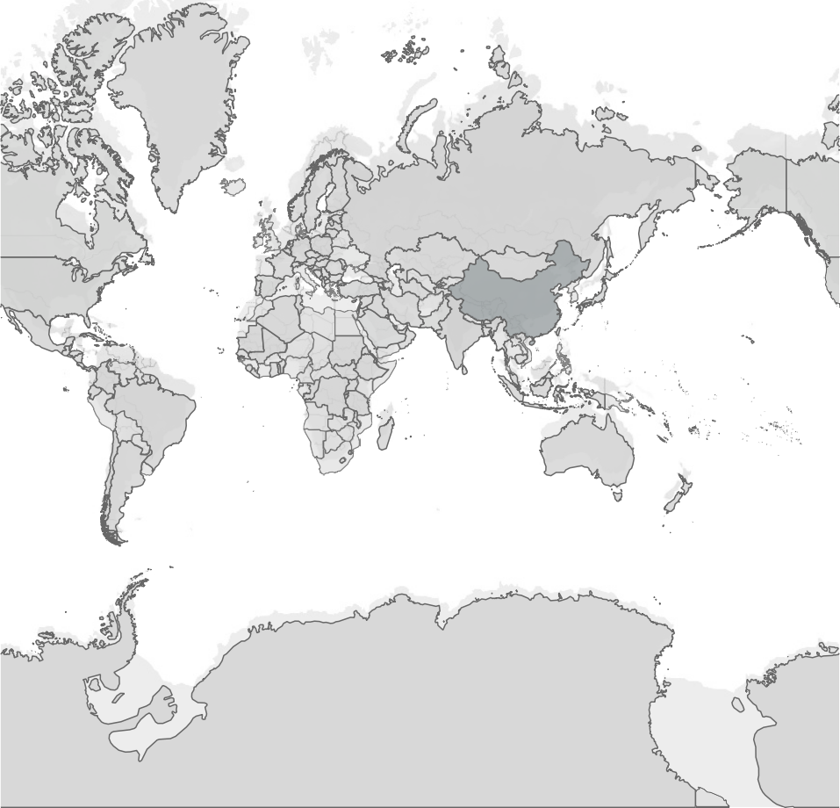

© 2023 Mapbox © OpenStreetMap

0 37,625

|  |  |  |  |  |  |  |
| --- | --- | --- | --- | --- | --- | --- |
| Emission of cement CO2 in each country | Sum of cement CO2 per capita every 5 years | A Graph between Coal CO2 and Flaring CO2 | Emission of Cumulative CO2 per 500M population | Representation of Cement CO2 per capita and Oil CO2 per capita | A Line Graph between Gas CO2 per capita and Flaring CO2 per capita | Plotting between eﬀusion of o.. |

26

24

22

20

18

16

Sum of Cement Co2 Per Capita

14

12

10

8

6

4

2

0

1975 1980 1985 1990 1995 2000 2005 2010 2015 2020

Year

|  |  |  |  |  |  |  |
| --- | --- | --- | --- | --- | --- | --- |
| Emission of cement CO2 in each country | Sum of cement CO2 per capita every 5 years | A Graph between Coal CO2 and Flaring CO2 | Emission of Cumulative CO2 per 500M population | Representation of Cement CO2 per capita and Oil CO2 per capita | A Line Graph between Gas CO2 per capita and Flaring CO2 per capita | Plotting between eﬀusion of o.. |

Coal Co2

|  |  |  |
| --- | --- | --- |
| 0 | 2,452 |  |
|  |
| 0.001 | 0 |
| 0.002 | 0 |
| 0.003 | 3 |
| 0.004 | 311 |
| 0.005 | 0 |
| 0.006 | 0 |
| 0.007 | 75 |
| 0.008 | 0 |
| 0.009 | 0 |
| 0.011 | 40 |
| 0.012 | 0 |
| 0.015 | 44 |
| 0.016 | 0 |
| 0.017 | 0 |
| 0.018 | 17 |
| 0.019 | 0 |
| 0.021 | 0 |
| 0.022 | 138 |
| 0.023 | 0 |
| 0.026 | 1 |
| 0.029 | 0 |
| 0.031 | 0 |
| 0.033 | 0 |
| 0.034 | 0 |
| 0.037 | 0 |
| 0.04 | 0 |
| 0.043 | 0 |
| 0.044 | 0 |
| 0.045 | 0 |
| 0.048 | 0 |
| 0.05 | 29 |
| 0.051 | 0 |
| 0.052 | 0 |
| 0.054 | 0 |
| 0.055 | 0 |
| 0.057 | 0 |
| 0.058 | 0 |
| 0.059 | 8 |

Flaring Co2

0 2,452

|  |  |  |  |  |  |  |
| --- | --- | --- | --- | --- | --- | --- |
| ssion of ent CO2 in h country | Sum of cement CO2 per capita every 5 years | A Graph between Coal CO2 and Flaring CO2 | Emission of Cumulative CO2 per 500M population | Representation of Cement CO2 per capita and Oil CO2 per capita | A Line Graph between Gas CO2 per capita and Flaring CO2 per capita | Plotting between eﬀusion of other industry CO2 per y.. |

Cumulative ..



Emi cem eac

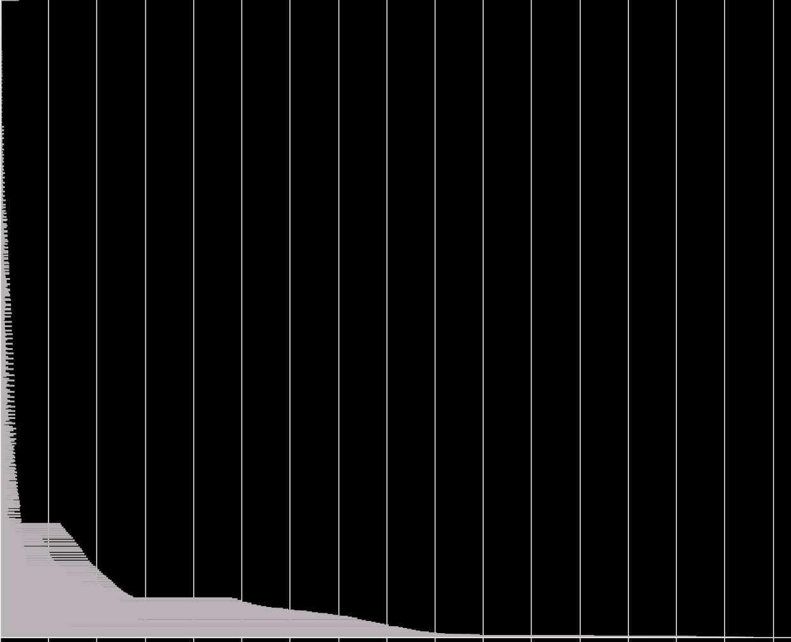

0M 500M 1000M 1500M 2000M 2500M 3000M 3500M 4000M 4500M 5000M 5500M 6000M 6500M 7000M 7500M 8000M

Population

|  |  |  |  |  |  |  |
| --- | --- | --- | --- | --- | --- | --- |
|  | A Graph between Coal CO2 and Flaring CO2 | Emission of Cumulative CO2 per 500M population | Representation of Cement CO2 per capita and Oil CO2 per capita | A Line Graph between Gas CO2 per capita and Flaring CO2 per capita | Plotting between eﬀusion of other industry CO2 per year | A bar graph between outrash of ﬂaring CO2 in each country |

Cement Co2..

Sum of cement CO2 per capita every 5 years

|  |  |  |
| --- | --- | --- |
| 0  0.001  0.002  0.003  0.004  0.005  0.006  0.007  0.008  0.009  0.01  0.011  0.012  0.013  0.014  0.015  0.016  0.017  0.018  0.019  0.02  0.021  0.022  0.023  0.024  0.025  0.026  0.027  0.028  0.029  0.03  0.031  0.032  0.033  0.034  0.035  0.036  0.037  0.038 |  |  |
|  |
|  |

Oil Co2 Per Capita

1

5,000

10,000

13,501

|  |  |  |  |  |  |
| --- | --- | --- | --- | --- | --- |
| ion of  lative CO2 per population | Representation of Cement CO2 per capita and Oil CO2 per capita | A Line Graph between Gas CO2 per capita and Flaring CO2 per capita | Plotting between eﬀusion of other industry CO2 per year | A bar graph between outrash of ﬂaring CO2 in each country | Representation of cement CO2 per capita and oil CO2 |

3600

A Graph between Coal CO2 and Flaring CO2

Emiss Cumu 500M

3400

3200

3000

2800

2600

2400

2200

2000

Gas Co2 Per Capita

1800

1600

1400

1200

1000

800

600

400

200

0

|  |  |  |  |  |  |
| --- | --- | --- | --- | --- | --- |
| f apita apita | A Line Graph between Gas CO2 per capita and Flaring CO2 per capita | Plotting between eﬀusion of other industry CO2 per year | A bar graph between outrash of ﬂaring CO2 in each country | Representation of cement CO2 per capita and oil CO2 | A Frequency polygon between ﬂaring CO2 per capita and ﬂari.. |

1100

Emission of Cumulative CO2 per 500M popul..

Representation o Cement CO2 per c and Oil CO2 per c

1000

900

800

700

600

Other Industry Co2

500

400

300

200

100

0

1975 1980 1985 1990 1995 2000 2005 2010 2015 2020

Year

Story 1

Representation of Cement CO2 per capita and O..

A Line Graph between Gas CO2 per capita and Flaring CO2 per capita

Plotting between eﬀusion of other industry CO2 per year

A bar graph between outrash of ﬂaring CO2 in each country

Representation of cement CO2 per capita and oil CO2

A Frequency polygon between ﬂaring CO2 per capita and ﬂaring ..

A Grid between oil CO2 and oil CO2 per capita

Flaring Co2

13K

12K

11K

10K

9K

8K

7K

6K

5K

4K

3K

2K

1K

Afghanistan

Africa Albania Algeria Andorra Angola Anguilla Antarctica

Antigua and Barbuda

Argentina Armenia Aruba Asia

Asia (excl. China & India)

Australia Austria Azerbaijan Bahamas Bahrain Bangladesh Barbados Belarus Belgium Belize Benin Bermuda Bhutan Bolivia

Country

Bonaire Sint Eustatius an.. Bosnia and Herzegovina

Botswana

Brazil British Virgin Islands

Brunei Bulgaria Burkina Faso

Burundi Cambodia Cameroon Canada Cape Verde

Central African Republic

Chad Chile China

Christmas Island

|  |  |  |  |  |  |  |
| --- | --- | --- | --- | --- | --- | --- |
| A Line Graph | Plotting between | A bar graph between | Representation of | A Frequency polygon | A Grid between oil | A Plot of ﬂaring CO2 |
| between Gas CO2 | eﬀusion of other | outrash of ﬂaring CO2 | cement CO2 per capita | between ﬂaring CO2 | CO2 and oil CO2 per | per year |
| per capita and Fl.. | industry CO2 per year | in each country | and oil CO2 | per capita and ﬂaring .. | capita |  |
|  |  |  |  |  |  |  |

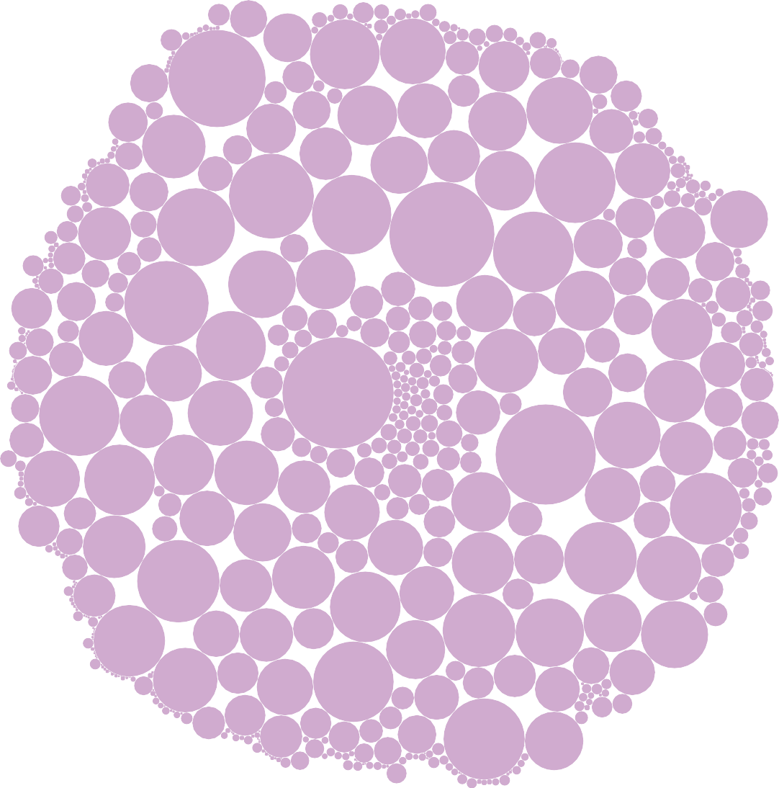

0.23

0.198

0.199

0.205

0.216

0.163

0.138

0.16

0.167

0.168

0.196

0.191

0.137

0.126 0.127

0.24

0.197

0.19

0.128

0.112

0.129

0.094

0.186

0.263

0.206

0.134

0.086

0.192

0.109

0.144

0.097

0.084

0.18

0.27

0.133

0.085

0.102

0.118

0.154

0.15

0.1

0.132

0.082 0.103

0.202

0

0.104

0.143

0.158

0.136

0.105

0.052

0.122

0.165

0.215

0.131

0.09

0.157

0.095

0.088

0.087

0.089

0.123

0.2

0.252

0.13

0.179

0.11

0.093

0.113

0.115

0.124

0.14

0.21

0.139

0.12

0.17

0.117

0.116

0.152

0.209

0.171

0.148

0.121

0.125

0.142

0.193

0.146

0.195

0.194

0.151

0.147

0.184

0.181

0.212

0.249

0.243

0.224

0.208

0.213

|  |  |  |  |
| --- | --- | --- | --- |
| A Frequency polygon between ﬂaring CO2 per capita and ﬂaring .. | A Grid between oil CO2 and oil CO2 per capita | A Plot of ﬂaring CO2 per year | A graph between discharge of ﬂaring CO2 per 100B popu.. |

Flaring Co2 Per Capita

Plotting between eﬀusion of other industry CO2 pe..

A bar graph between outrash of ﬂaring CO2 in each country

Representation of cement CO2 per capita and oil CO2

2000

1800

1600

1400

1200

1000

Flaring Co2

800

600

400

200

0

-200

0.001 0.003 0.005 0.007 0.009 0.011 0.013 0.015 0.017 0.019 0.021 0.023 0.025 0.027 0.029 0.031 0.033 0.035 0.037 0.039 0.041 0.043 0.04

|  |  |  |  |
| --- | --- | --- | --- |
| A Grid between oil CO2 and oil CO2 per capita | A Plot of ﬂaring CO2 per year | A graph between discharge of ﬂaring CO2 per 100B populat.. | A horizontal bar graph between other industry CO2 .. |

Oil Co2 Per Capita



A bar graph

Representation of

between outrash cement CO2 per capita of ﬂaring CO2 in .. and oil CO2

A Frequency polygon between ﬂaring CO2 per capita and ﬂaring ..



0.198

0.125

0.158

2.098

0.066

0.0 212.1

|  |  |  |  |
| --- | --- | --- | --- |
| A Plot of ﬂaring CO2 per year | A graph between discharge of ﬂaring CO2 per 100B populat.. | A horizontal bar graph between other industry CO2 and cem.. | Representation of count of CO2 new and Trade CO2 sha.. |

1700

Representation A Frequency polygon A Grid between oil of cement CO2 between ﬂaring CO2 CO2 and oil CO2 per per capita and oi.. per capita and ﬂaring .. capita



1600

1500

1400

1300

1200

1100

1000

900

Flaring Co2

800

700

600

500

400

300

200

100

0

1975 1980 1985 1990 1995 2000 2005 2010 2015 2020

Year

Representati on of cement CO2..

800B

A Frequency polygon between ﬂaring CO2 per capita and ﬂaring ..

A Grid between oil CO2 and oil CO2 per capita

A Plot of ﬂaring CO2 per year

700B

|  |  |  |
| --- | --- | --- |
| A graph between discharge of ﬂaring CO2 per 100B populat.. | A horizontal bar graph between other industry CO2 and cem.. | Representation of count of CO2 new and Trade CO2 share |

600B

500B

400B

Population

300B

200B

100B

0B

0K 5K 10K 15K 20K 25K 30K 35K 40K 45K 50K 55K

Flaring Co2

Representati on of cement CO2..

A Frequency polygon A Grid between oil between ﬂaring CO2 CO2 and oil CO2 per per capita and ﬂaring .. capita

A Plot of ﬂaring CO2 per year

A graph between discharge of ﬂaring CO2 per 100B populat..

Representation of count of CO2 new and Trade CO2 share

A horizontal bar graph between other industry CO2 and cem..

Cement Co2 Other Industry Co2

0K 10K 20K 30K 40K 50K 60K 70K 80K 90K 100K 110K 120K 130K

Value

140K

Representati on of cement CO2..

A Frequency polygon A Grid between oil between ﬂaring CO2 CO2 and oil CO2 per per capita and ﬂaring .. capita

A Plot of ﬂaring CO2 per year

A graph between

A horizontal bar graph

discharge of ﬂaring between other

CO2 per 100B populat.. industry CO2 and cem..

Representation of count of CO2 new and Trade CO2 share

0K 5K 10K 15K 20K 25K 30K 35K 40K 45K 50K 55K 60K 65K 70K 75K 80K 85K 90K 95K

Count of Co2 New (1)